
Club project spotlights

WRAP WONDERS CLUB
Students worked on an eco–friendly craft project – Designing and Making Colourful book stand and pen stand using reusable, recyclable and biodegradable materials.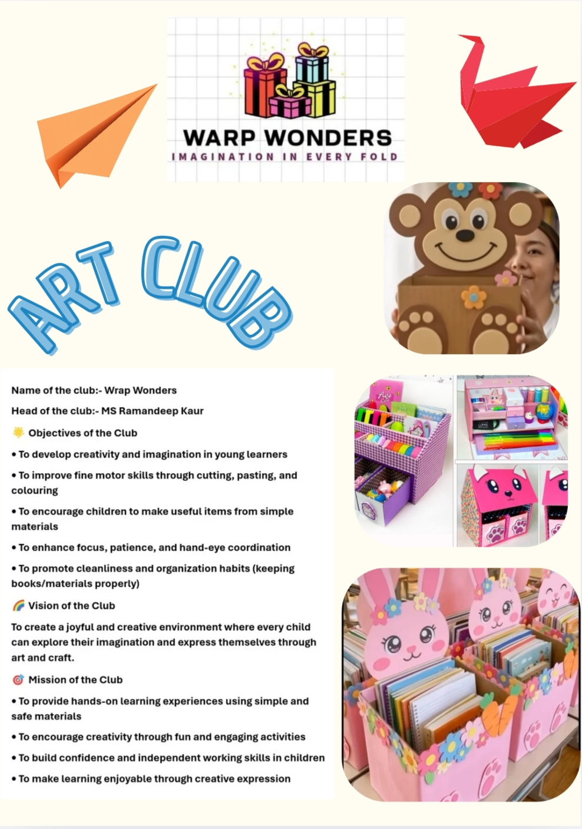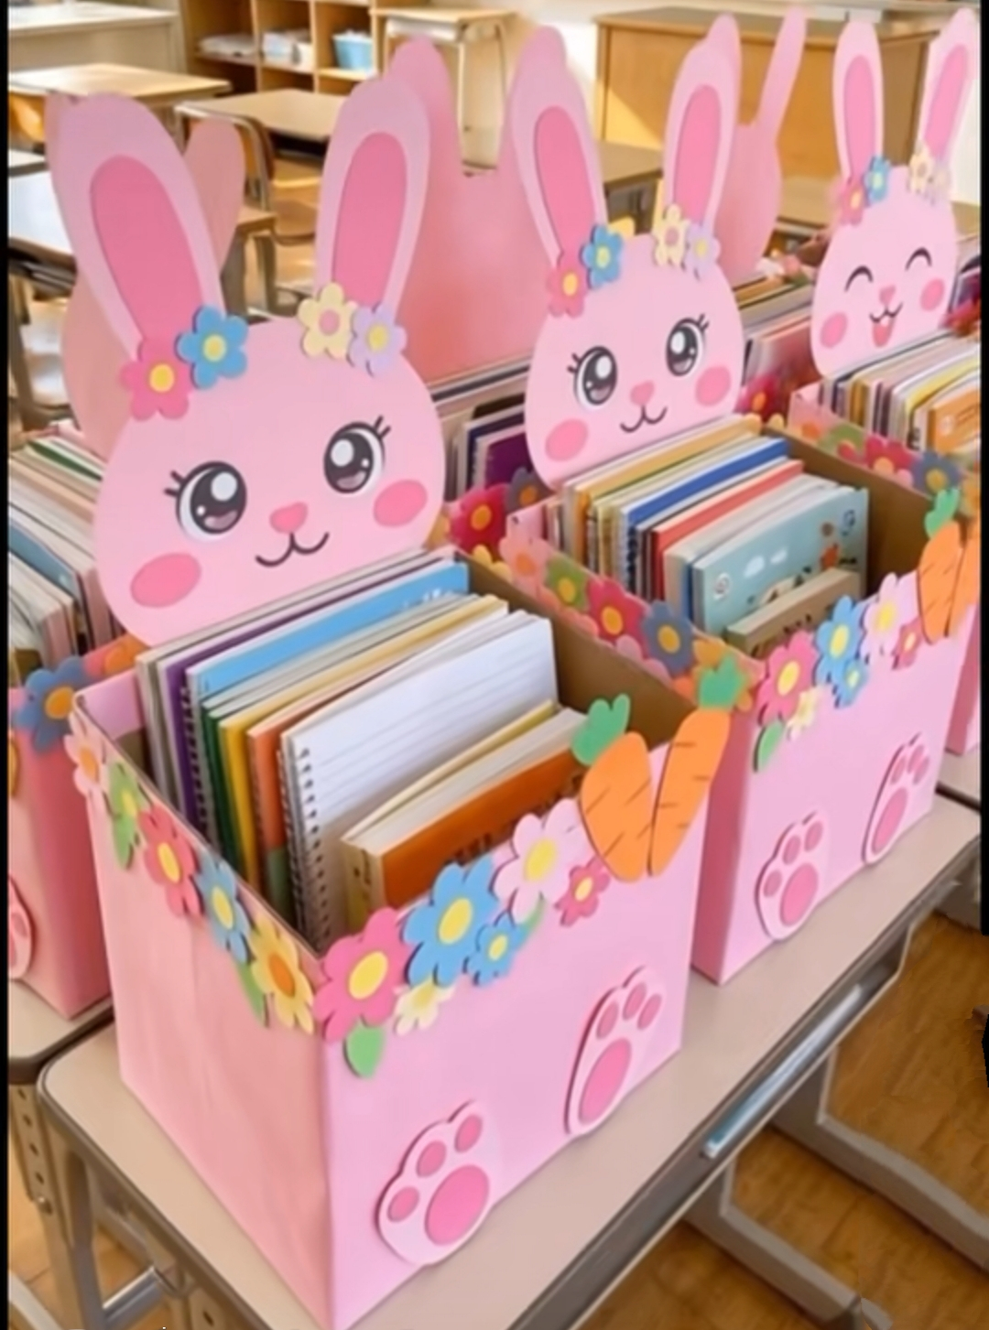
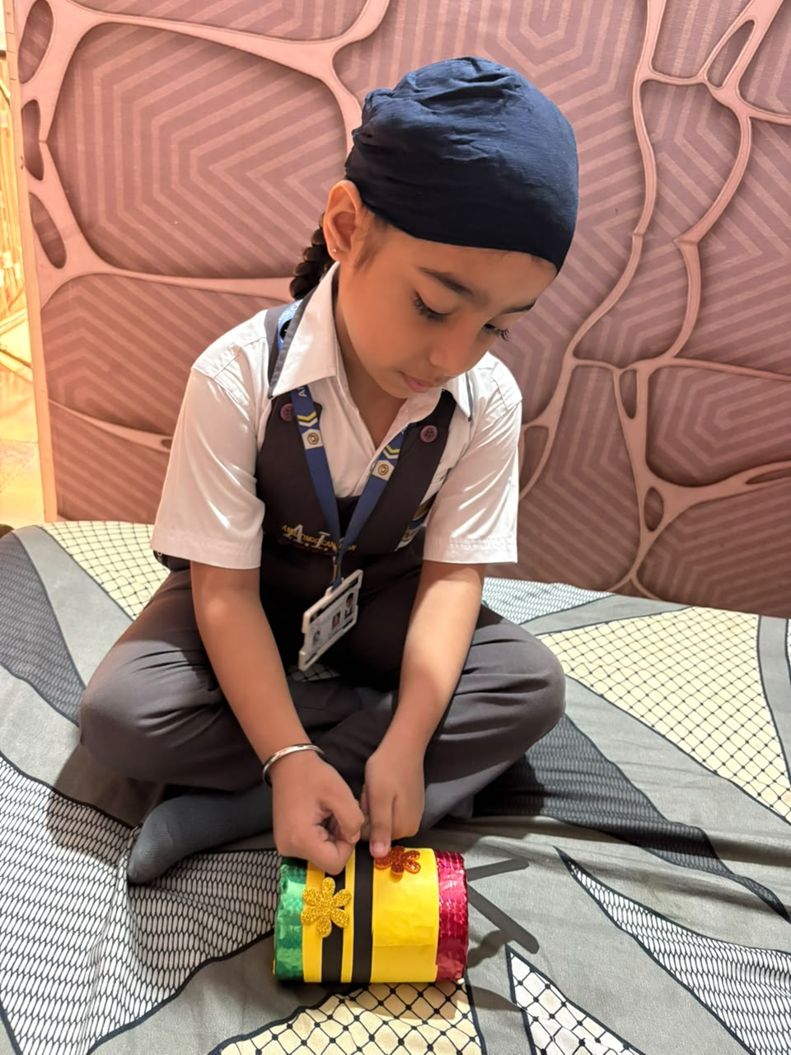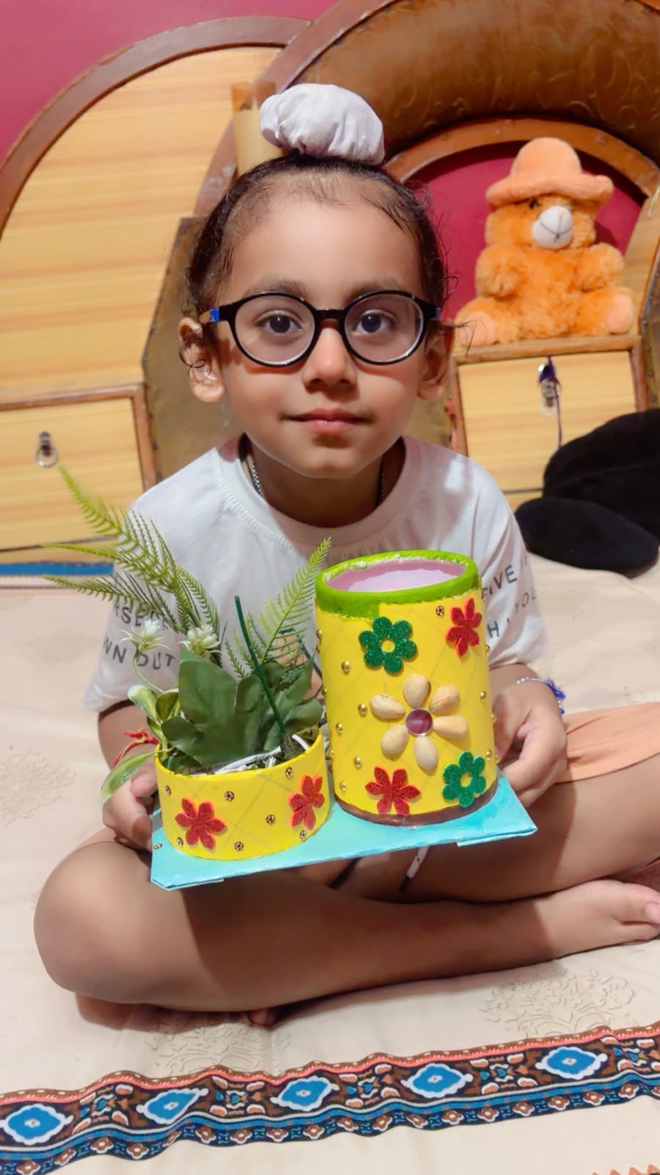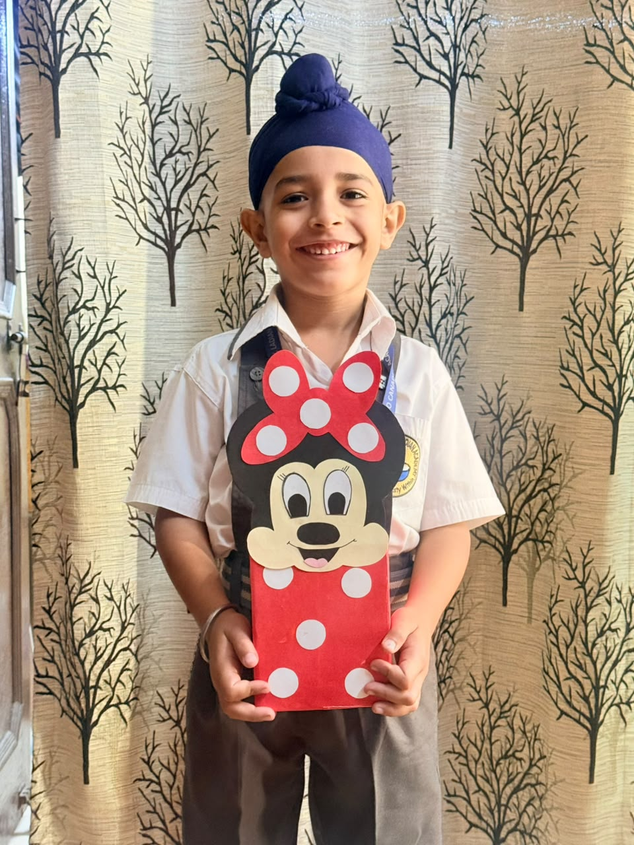
Student Voices : • Students felt excited to create their own designer stands
• They learnt that small steps like using cardboard instead of plastic help protect the environment.
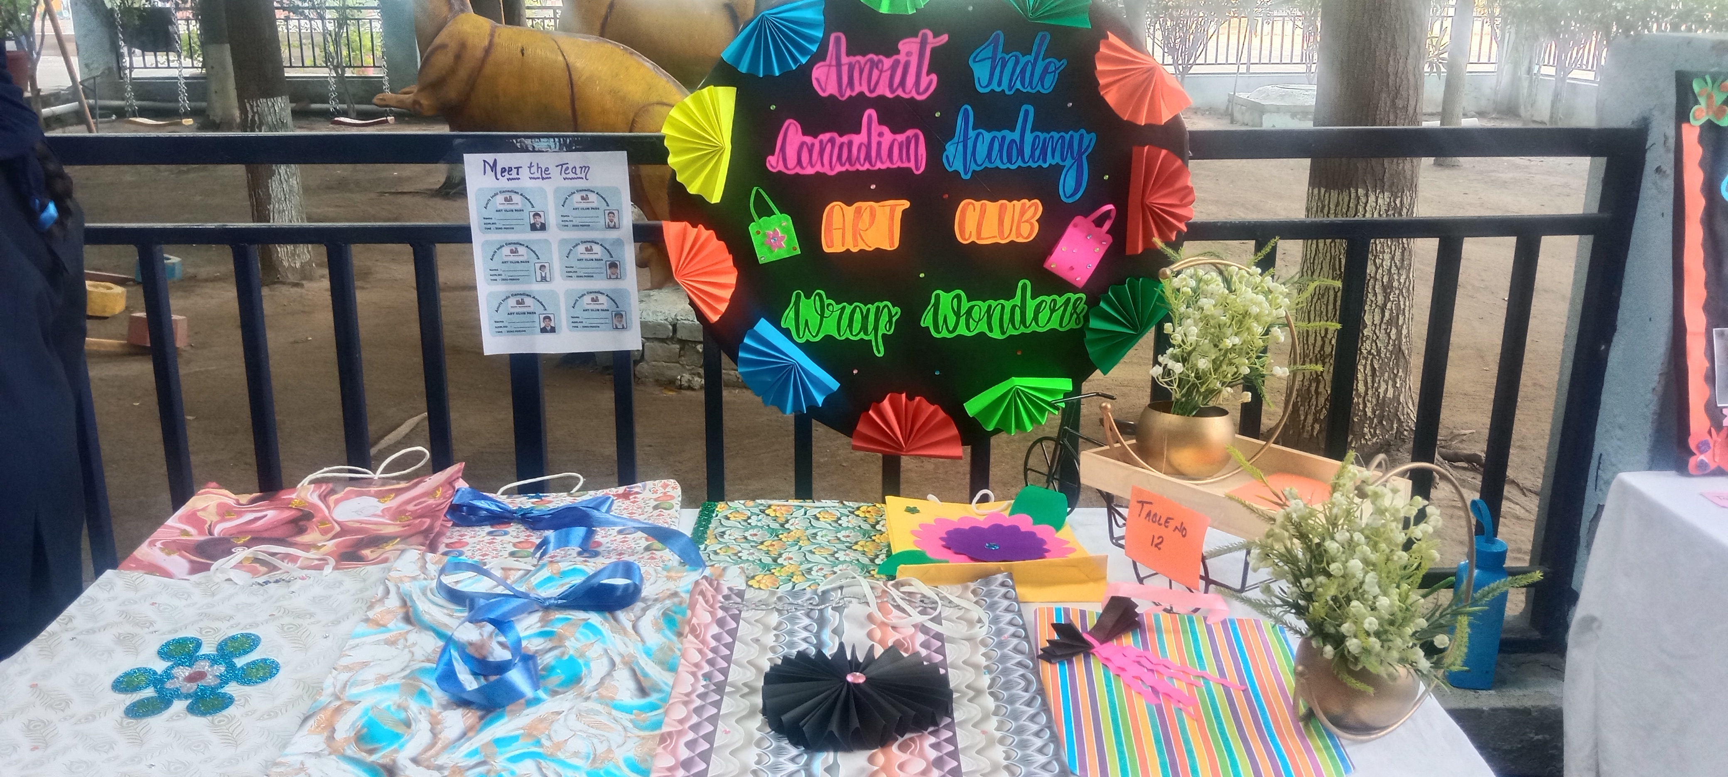
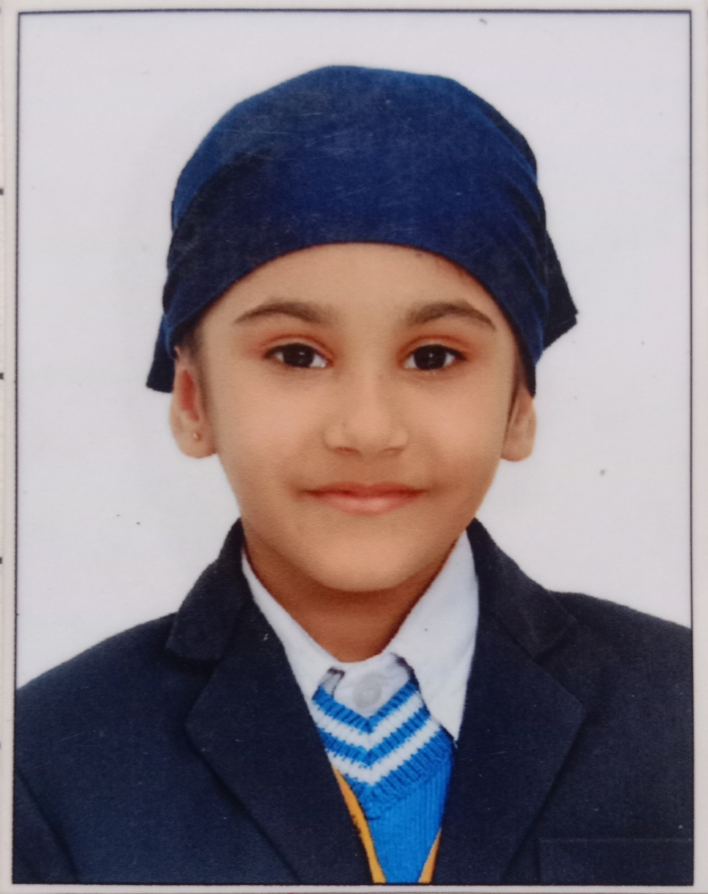
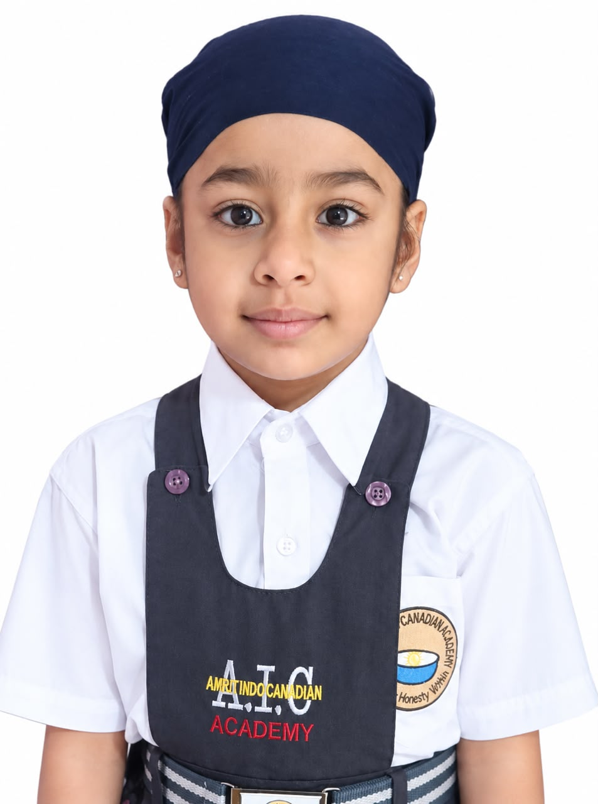
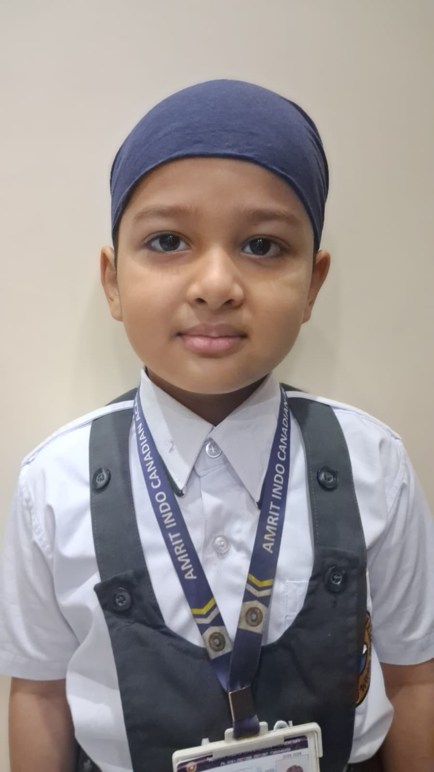
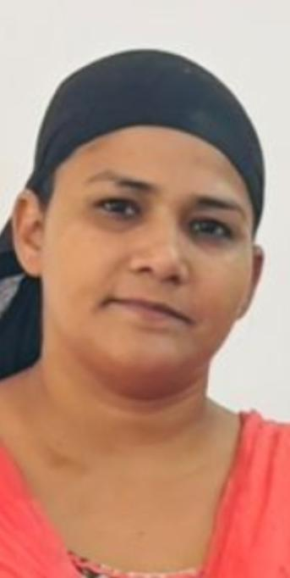
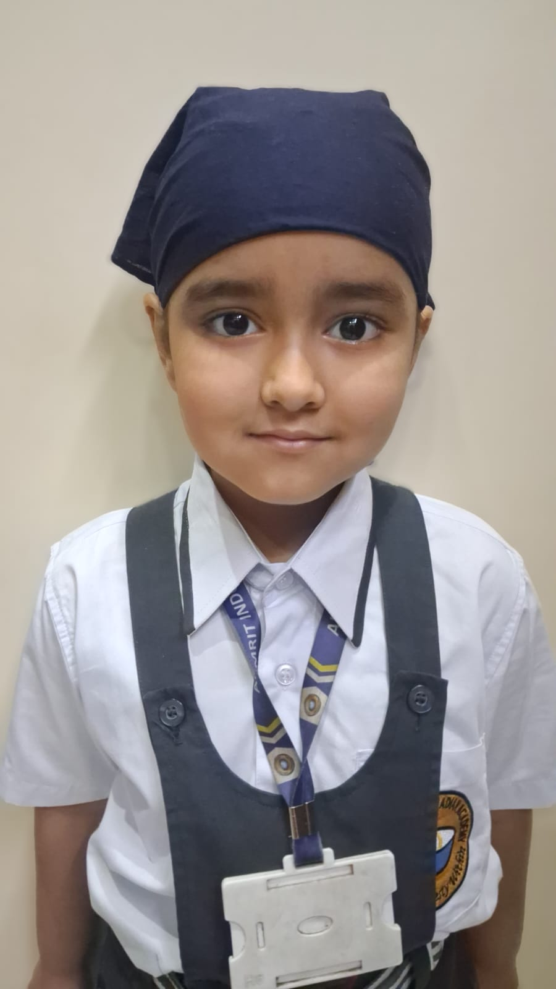
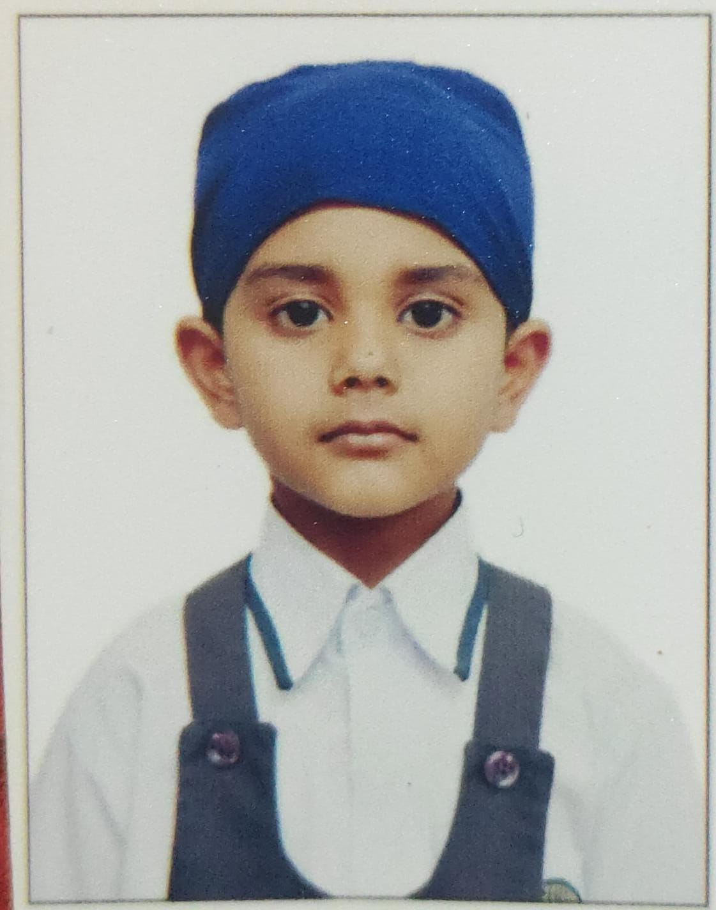
WRAP WONDERS SMALL CHANGE BIG DIFFERENCE RAMANDEEP KAUR WRAP WONDERS

Project Report and Skill Development
DEEPER DIVE
RAMANDEEP KAUR-24.11.2025
Project Goals:

Process/ Steps:

Skills Learned :
Challenges and solutions :
Meet the Team :
Collected old cardboard chart papers and decorative materials.

.
Promote eco-friendly habits among students.
Paper tearing → Students learned to apply glue carefully and fold gently.

Material shortage → Reused old papers, covers and craft scraps.
Creativity and innovative designing.
Fine motor skills – folding, cutting, pasting.

Students designed, decorated and personalised their stands
Encourage reduction of plastic use through handmade book stand and pen stand

